

The Rules of Relay Ball

Invented by Zane Gardner



Relay Ball Rules
Relay ball is an invasion game for teams of equal numbers with a maximum of seven on each side.

Main Concept:

The ball should be a mini basketball, can be bounced and is a size that is comfortable for the players to hold in two hands and to be passed to teammates in relay so every player feels part of the game.

We are developing Relayball to appeal to all ages and abilities. The standard rules can be modified to suit the players experience & understanding.

Game Length:

The game consists of two 15-minute halves. The clock will run continuously during the first half and the first 14 minutes of the second half.

*The supervisor has the authority to shorten any game due to time restraints or any other reason.

Each team will receive one time out per half.

Team Structure:

In the game of Relay Ball, you have two opposing sides: An Offense and Defense.

This can be:
1 vs. 1 - Centers
2 vs. 2 - One Center & One Midfielder
3 vs. 3 - One Center, One Midfielder, & One Goalie.

Any additional players would be considered a substitute on the team.

Court Layout:

An Outdoor Basketball court (64 in x 52 in) is used as the court size.

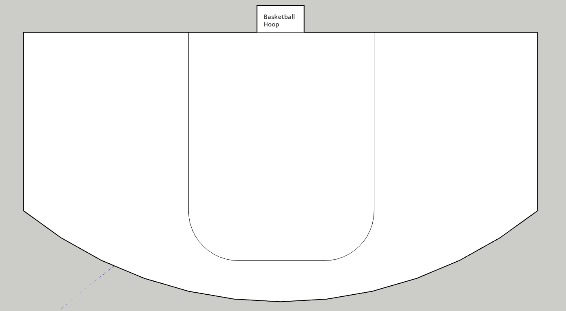

The Game Starts with a coin toss. The winner of the toss will have their Goalie receive the ball. They will have to move the ball forward from the basketball hoop. You cannot travel backwards with the ball.

When a goal is reached, teams switch sides. A goal is worth 1 point. The goal used is typically a Trashcan Bucket or a basketball hoop. A mini basketball or hacky sack if using a Trashcan is the standard type of ball to use.

The Ball needs to be passed to everyone on your team (Relayed) before you can score a goal. This does not apply in 1 vs. 1 games.
5 points to match/rounds is declared the winner of the match. There is no overtime.

When a ball is in your possession, you must be traveling with the ball or dribbling the ball like a basketball. You cannot stop and stand still with the ball.

The ball can only be stolen by the opposition when the ball is traveling in the air between passes or intercepted during an attempt to score the ball into the goal.
The ball needs to be thrown into the goal. It cannot be traveled in.

Penalties:

- Stopping is a foul.
- Charging of the Defense or Offense is foul.
- Tackling other players is a foul.
- Striking the ball when it’s in contact with someone else is a foul.

Each match consists of two games (also called rounds). The first team to score 5 points is declared the winner of that game (or round). The team that wins two games.

